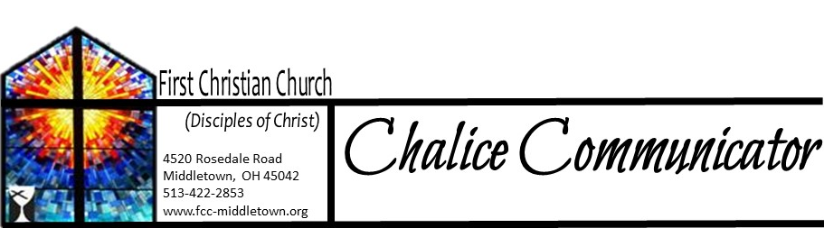

Senior Pastor: Rev. Connor Thompson
Assoc. Pastor: Minister Jeff Wilder
Music Director: Michael Hefner
Moderator: Roger Byrd
Elders: Sharon Amburgey
Natalie Byrd
Zola McClish
Karen Powers
Lora Schueller
Guy Stone
Marilyn Strong
Karen Thompson
______________________________
SEE YOU ON SUNDAYS
Worship – 10:30 a.m.
Bible Study-Tuesdays
@ 1 PM & 7 PM
________________________________
STATISTICS: Attendance Offering
12/6 $2335.00 12/13 $3070.00 12/20 $3516.49 12/27 $ 900.00

Important numbers/emails:
Pastor Connor Thompson (513) 594-0070 pastorconnorlthompson@ gmail.com
Assoc. Pastor Jeff Wilder (513) 594-5421 mastermasonjeff@gmail.com
Elder Co-chairs
Karen Powers (513) 539-7286
Sharon Amburgey (937) 746-9120



December 29, 2020 Number 12
Connor's Corner

To Start A New Year
Anonymous
"A new year is unfolding—like a blossom with petals curled tightly concealing the beauty within.
Lord, let this year be filled with the things that are truly good—with the comfort of warmth in our relationships, with the strength to help those who need our help and the humility and openness to accept help from others.
As we make our resolutions for the year ahead, let us go forward with great hope that all things can be possible—with your help and guidance."

Here we are arriving to the year 2021. There were times I was starting to be convinced that we would never leave the year 2020. It has been a long year, and a rollercoaster of a year. We have learned about social distancing, and quarantine, and isolation. Our meetings have been conducted online, worship live-streamed, and holidays celebrated small. We have lost loved ones, and had to grieve in new environments, churches and funeral homes not full of people, and services held outside at gravesides, rather than full services indoors.

We have celebrated both Easter and Christmas from home, rather than gathered singing together with Joy in the fellowship of the Sanctuary, But God is still present, and good has still happened.

If you would have told me this time last year that all of the things, that would happen in 2020, I would have said the end of the world had come. Now, there is no doubt that in many ways the world has slowed, but in others the world has incredibly sped up.

Through everything that has happened, this congregation has continued to strive to show Good to the world. We hosted parking lot retirement parties and graduations. We had drive thru food drives, and helped distribute free food to those in need. We continued to support the Salvation Army’s efforts at Thanksgiving and Christmas, while also helping two families directly. We provided a place for families in this community to come and celebrate their children’s achievements in scouting, including an Eagle Scout Court of Honor for one scout, and a Eagle Project for another. We opened our building for a safe environment for scouts to come and learn life skills, which will carry them for the remainder of their lives. We provided blanket and towels, and personal items to those in need in our community. We also helped foster the start of the Middletown Youth Coalition, which is growing and diversifying every day.

We increased our visitation through social distanced visits and phone calls to those who are home bound. As well as providing continued support to those who needed us at their time of loss.

A few weeks ago, I was having a discussion of just how short we had come from what I had hoped for the year 2020, and then I realized, we did not accomplished what I had hoped, but we accomplished different things! And so much more, than I could have imagined. So as we start a new year, we still have so many things to accomplish, and they will be good!

Happy New Year!
Pastor Connor

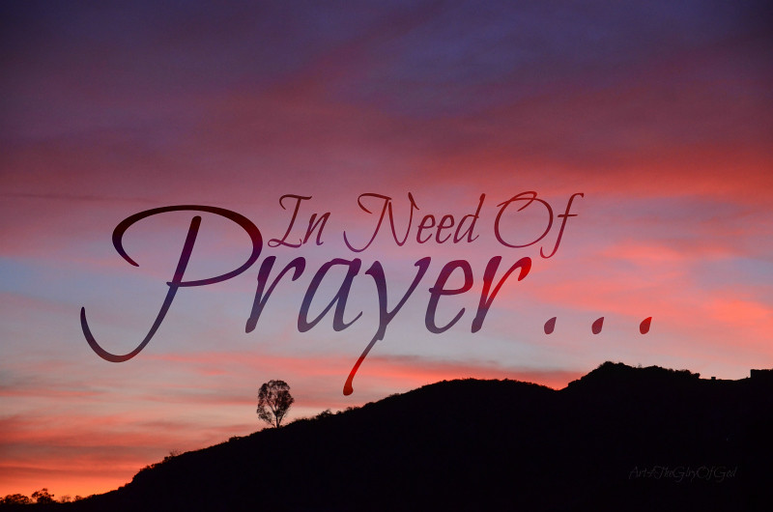

Prayer List:
Health: Mike Blevins, Linda Neanover, Allen Stone, Guy Stone
Special Needs: Barbara Cessna, Jean Greathouse, Lois Murphy
Other: All those affected by disasters and pandemic. Caregivers, first responders, the homeless, heroin epidemic, racism and all human rights, our Country & World, war, violence, our church, congregation and church leaders
ELDER’S MOMENT
As we come to the end of this calendar year, we reflect on the past months. No matter how many or how few years we've lived, this was one for the record books. We were open for in person worship, we closed, we reopened and closed again. We look forward to opening for in-person services very soon. Due to the creativity of a young college student a few years ago, we were set up to live stream our services way in advance of it becoming a necessity. Thanks to the foresight of that young man, who is now our Senior Pastor, and the work of our dedicated Tech Team volunteers, we have been able to have worship each week. Whether we meet in person, live stream or find it necessary to tape ahead of time, we are blessed each week in being able to have church. We thank God for the opportunities we have to hear a meaningful message, listen to beautiful music, and share communion in remembrance of our Lord and Savior. We've learned to change some things up in recent months and we've benefited by doing so. After quickly learning we could Zoom our Elder meetings, we safely met from the comfort of our own homes. Many of us are enjoying bible study each Tuesday and appreciate Pastor Connor and Pastor Jeff leading our classes, again through Zoom. Our members have stayed in touch with each other, prayed together, sometimes shared sorrow, shared stories and many smiles throughout the year. We will move forward together, as a Church family, because of our undying faith. Our prayers are with each of you.
Sharon and Karen


We are so grateful for your support to My Very Own Blanket, helping us bring more love, comfort and hope to children in foster care! If we all do a little … together we can accomplish and give a lot! Thank you for being a part of our mission and charity.
Jessica Rudolph, Founder and CEO,
My Very Own Blanket Nonprofit Charity, 407 W. Main Street, Westerville, Ohio


To the Congregation, Elders, and Board,
Thank you for your gift to me at Christmas. It was unexpected and truly appreciated. I get asked time and time again, why I serve here, and I always tell people, because they treat you like family. It has been a pleasure to serve on the staff this last year, as I am able to serve you, who are so very dear to me. I look forward to what we can do in the year 2021.
Happy New Year!
Pastor Connor

Dear Church Family,
My family and I would like to take this opportunity to thank all of you for the kindness you have shown to us during this year, and during such a trying time the last month. Your love and support to us, your cards, Emails, letters and gifts have been so kind and generous, more so your prayers are what is most appreciated and needed. It is an honor and a privilege to be part of this church family. Your love and acceptance truly is one of the greatest gifts we have ever received. We are so grateful for our church Family.
Love
Pastor Jeff.

Dear First Christian Church,
I wanted to sincerely thank all the elders and congregation members for the beautiful letter and most generous gift I received on Christmas Eve after the service. I am blessed to be able to serve at FCC in providing music for the services.
Many blessings,
Michael Hefner

CWF NEWS
Sarah Circle met at 6:30 on December 3rd at the church. We brought appetizers and desserts to the meeting. We have made another 14 tied fleece blankets to be given to the My Very Own Blanket organization in Columbus. We thank Zola for delivering these for us. These blankets will go to foster children in the state of Ohio. Each child who receives a blanket is allowed to take that blanket wherever he or she goes in the fostering system.
Sarah Circle will not meet for a couple months in the wintertime. We will resume meeting soon after that. We will keep the circle members informed as to when our meetings will resume.
Several of us have enjoyed the Bible Study “Incarnation” which Connor led for us. We thank Pastor Connor for his assistance in this project. Our “Seamless” Bible Study will resume in January.
We wish our church family a Happy and Healthy New Year! Marilyn Chamberlain

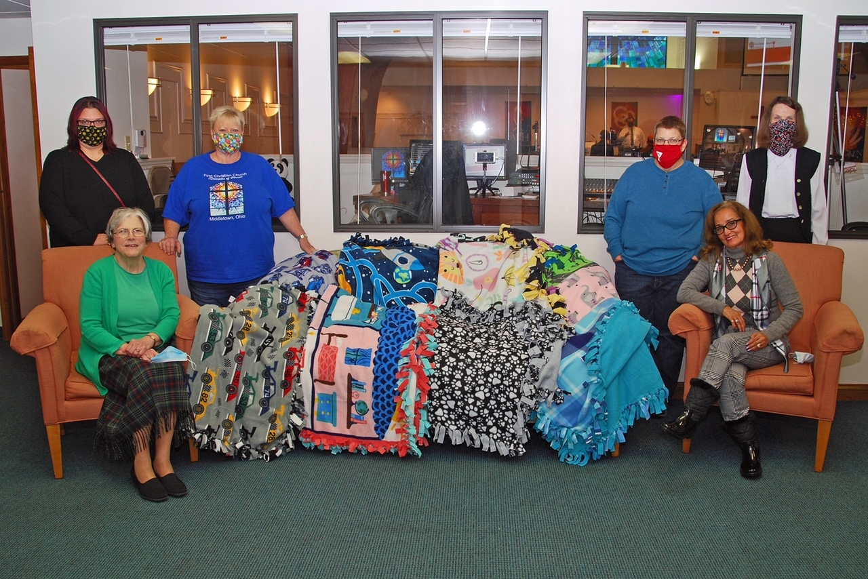
Several Sarah Circle members and a sample of their blankets.

Outreach Notes:
We set goals for Outreach during this holiday season which were different than our normal Thanksgiving and Christmas activities. We had to think outside the box as we did not adopt families through the Salvation Army this year. We chose to not ask our members to go out and shop during the pandemic. We purchased new blankets for the homeless and part of this was made possible by an anonymous gift. We dropped off monetary donations to the Salvation Army at Thanksgiving and Christmas and were pleasantly surprised to hear our latest and largest donation would be matched. We received another anonymous gift from a family outside of our congregation to provide for families in need. We met with two families recommended by Pastor Jeff and were able to gift them funds to help them through the holidays. This not only helped with Christmas for a total of six children and three adults, but also guaranteed a nice Christmas meal. We purchased gift bags for the students at Central Academy to use for the gifts they were wrapping for family members since we could not help wrap this year. We purchased gift bags and filled them so each of 29 residents at Close to Home Assisted Living received a Christmas gift and a personalized Christmas card from our Church. We give thanks to our congregation for continued support of our Outreach programs. We give thanks to friends, neighbors and family outside of our congregation who know how important our Church is to us and offer support. Most of all, we are thankful to God for always giving us what we need to be able to reach out to others.
May the new year bring blessings to you!
Sharon and Linda, Outreach Co-chairs

Scouting at FCC in 2020
In January we chartered a Venturing Crew at First Christian Church. This ended a nearly 40 hiatus from hosting scouting for this congregation. Venturing Crew 87 (Borrowing the number from our old Boy Scout Troop) was chartered with 4 male youth and 4 female youth as well as 6 adults to serve as Advisors and on the Crew Committee. These were both members of our congregation as well as those from our community.
In October, we began allowing another unit to meet in the church as their chartering organization was not allowing them to meet as all. So, we began hosting Scouts BSA Troop 250. This unit since it resumed meetings in October has celebrated an Eagle Scout Rank being earned, as well as a half dozen other rank advancements being earned.
The goal of scouting is to create well rounded citizens, who value leadership, service, and faith, among a few others, and it is the churches calling to support the creation of youth under those principals.



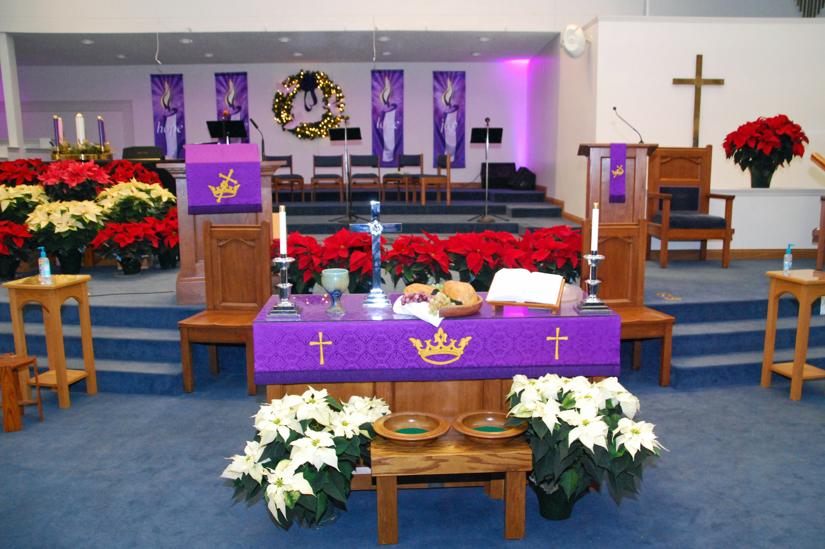

We are grateful to the following for the beautiful poinsettias which were in memory and/or honor of love ones this Christmas:

Connor Thompson Harold & Betty Henderson, Charles ‘Tommy’ Thompson
Crystal Watson Charles & Mary Watson
Dorice Perkins Husband, Mother, Dad, Brothers, Cousin & Friend
Esther Saxbury Richard Saxbury & Parents
Guy Stone Our Loved Ones
Helen Morgan Husband & Parents
Janice Kash My daughter, Penny
Jeff & Kelly Wilder Sister, Friends & Loved Ones
Joann Grimes Loved Ones
John & Beth Heinkel Charles & Helen Hall, Phyllis Heinkel
Larry & Marilyn Our Parents - Mr. & Mrs. James Brewer,
Chamberlain Mr. and Mrs. Robert Chamberlain
Larry & Mary Back Ruby & Larry Back & Harley, Leona & Carol Cartwright
Linda Poynter Husband & Parents
Dave & Lora Schueller Loved Ones We’ve Lost
Marilyn Strong Loved Ones
Mike & Shelly Blevins Brother, Arnaldo Ariaf
Sharon Amburgey Lois Hafer & Loved Ones
Tim & Karen Powers Parents
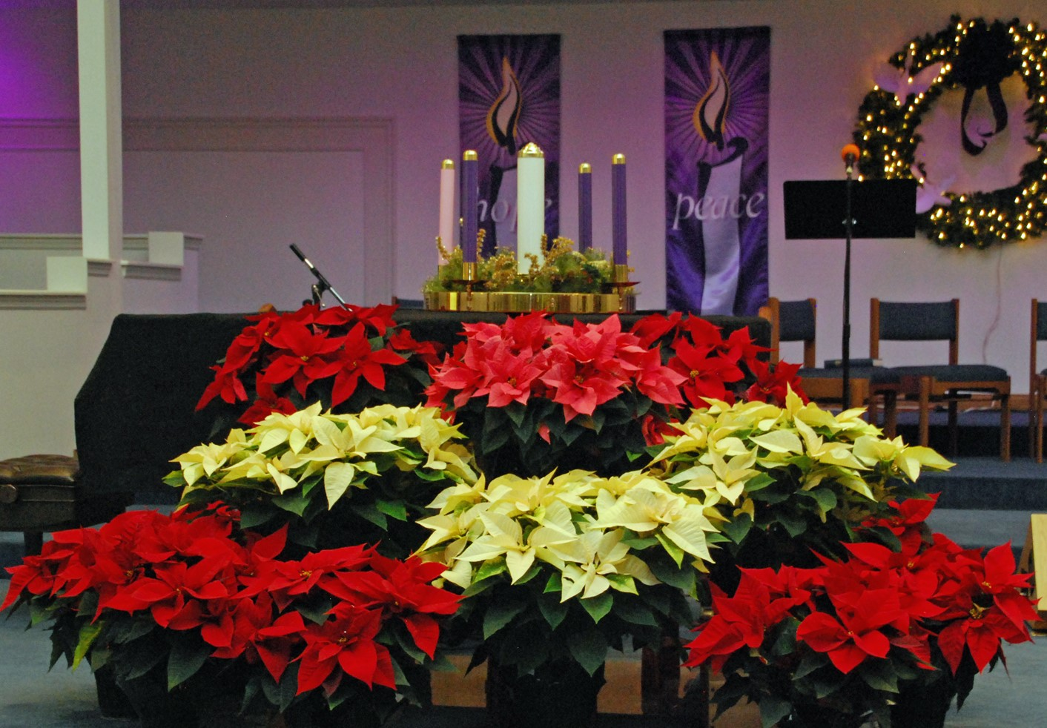

January, 2021 Birthdays
Sunday | Monday | Tuesday | Wednesday | Thursday | Friday | Saturday
 |  |  |  |  | January 1   | 2
3 | 4 | 5    1PM & 7 PM | 6 | 7  Sarah Circle  7 PM | 8 | 9
10  Sharon Amburgey | 11  Betty Stacy | 12  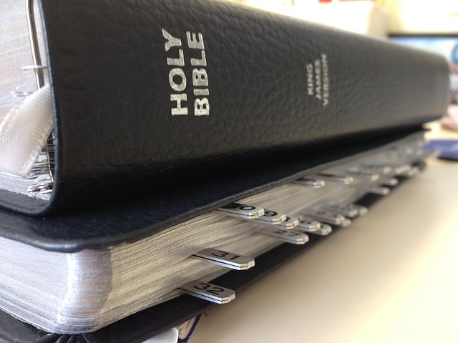  Bible Study  1 PM & 7 PM | 13 | 14 | 15 | 16
17 | 18  Elder Mtg.  7 PM | 19  Bible Study  1 PM & 7 PM | 20 | 21  Peggy Byrd | 22 | 23
24  Board Mtg. following church | 25 | 26  Bible Study  1 PM & 7 PM | 27  MacKenzie Lovin | 28 | 29 | 30
31

