Prelude
Please use this time to prepare your heart and spirit for worship.

There is a prayer station in the northeast corner of the sanctuary. Please use this area at any time during the worship to pray or light a candle for someone.

If you have a prayer request, please fill out a yellow card in the pew. You may pass it toward the center aisle during the singing of the Hymn of Invitation.

Welcome & Announcements

* Songs of Praise 10,000 Reasons Screen You Are My All in All CP #78

Opening Prayer

Children’s Moment Song
This Little Light of Mine

Children’s Moment
Scripture John 2:1-11
Sermon “At the Wedding” Rev. Tracy Siegman
Invitation to Discipleship
If you would like to make a confession of faith or rededicate your life,
please come forward during the singing of the Invitation Hymn
or talk to Pastor Tracy following service.
* Hymn of Invitation #5 (v.1,2 & 3)
O for a Thousand Tongues to Sing
Pastoral Prayer & Lord’s Prayer (Prayer said with trespasses)

January 14, 2018
Communion Hymn #386
We Come as Guests Invited
Welcome to the Table
Words of Institution
Communion Prayer
Sharing Sacred Meal
We celebrate communion every Sunday. All who believe in Jesus Christ are
welcome to partake of communion. As the bread is passed, please take and
eat. Please reserve the cup. We will share the cup together when instructed.

Offering (Invitation and Collection)
* Doxology #46
* Prayer of Dedication
* Closing Hymn CP#181
May You Run and Not Be Weary

* Benediction
Postlude

* Please stand if you are able

Hearing Assistance: We have hearing assistance units available in the sound booth. Please feel free to get one at the beginning of worship. Please return to sound booth at the end of worship.

Minister: Rev. Tracy Siegman
Worship Leader: Roger Byrd
Music Director: Rachel Eve Davis
Elders: Martin Schaefer & Matt Lyons
Deacons: Crystal Watson, Rick & Cathy Treadway,
Judy Lemmert & Angie Otis
Sound & Video Booth: Larry Steele & Martin Schaefer

CALENDAR

Today: 9:30 am Sunday School
10:30 am Worship
Monday: 7:00 pm Elders Meeting
Wednesday: 2:01 pm Shalom Meeting
6:00 pm Choir Practice

There will be no Bible Study Wednesday,
January 17th.

Prayer Concerns:



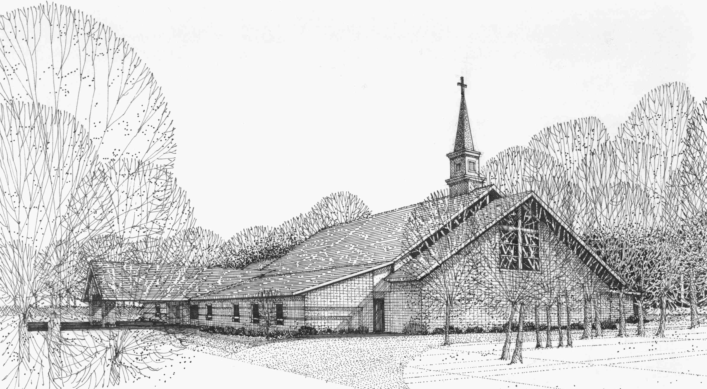

Our Vision
We are the Christian Church (Disciples of Christ) where ALL are welcome. We are faith based, following the teachings of Jesus Christ, and carrying the word to others by serving our community and beyond

First Christian Church, 4520 Rosedale Rd., Middletown, Ohio 45042
Phone: 513-422-2853 Fax: 513-422-4530
fccmiddletownoh@gmail:com
Web Site: www.fcc-middletown.org

