Prelude
Please use this time to prepare your heart and spirit for worship.

There is a prayer station in the northeast corner of the sanctuary. Please use this area at any time during the worship to pray or light a candle for someone.

If you have a prayer request, please fill out a yellow card in the pew. You may pass it toward the center aisle during the singing of the Hymn of Invitation.

Welcome & Announcements
We welcome you to our special “Music Sunday” service

* Opening Hymns Multiplied Screen
Let the Whole Creation Cry #21

Opening Prayer

Anthem Come Flood This Heart of Mine Chancel Choir

Children’s Moment Song #286
This Is the Day

Children’s Moment Pastor Tracy
Anthem God is Our Refuge Chancel Choir
Scripture Acts 2:1-21, Ezekiel 37:1-14
* Song of Praise Be Thou My Vision #595
Sermon “What Does the Spirit Do?” Rev. Tracy Siegman
Invitation to Discipleship
If you would like to make a confession of faith or rededicate your life,
please come forward during the singing of the Invitation Hymn
or talk to Pastor Tracy following service.
* Hymns of Invitation
The Church’s One Foundation #272 (v. 1,2,5)
O for a Thousand Tongues to Sing #5 (v. 1,3)
May 20, 2018
Pastoral Prayer & Lord’s Prayer (Prayer said with trespasses)
Communion Hymn (CP) #158
Come to the Table of Mercy
Welcome to the Table
Words of Institution
Communion Prayer
Sharing Sacred Meal
We celebrate communion every Sunday. All who believe in Jesus Christ are
welcome to partake of communion. As the bread is passed, please take and
eat. Please reserve the cup. We will share the cup together when instructed.

Offering Song Here I Am, Lord #452
Offering (Invitation and Collection)
* Doxology #46
* Prayer of Dedication
* Closing Hymns
Breathe on Me, Breath of God #254 (v. 1,3)
God of Grace and God of Glory #464 (v. 1,3,4)
* Benediction
Postlude

* Please stand if you are able
Hearing Assistance: We have hearing assistance units available in the sound booth. Please feel free to get one at the beginning of worship. Please return to sound booth at the end of worship.

Minister: Rev. Tracy Siegman
Worship Leader: Marilyn Chamberlain
Music Director: Rachel Eve Davis
Elders: Marilyn Strong, Matt Lyons
Deacons: Natalie Byrd, Heather Lyons, Zola McClish,
John Otis, Connor Thompson
Sound & Video Booth: Larry Steele & Cliff Thompson

CALENDAR

Today: 9:30 am Sunday School
10:30 am Worship
Monday 7:00 pm Elders Meeting
Tuesday: 7:00 pm Bible Study
Wednesday: 2:00 pm Bible Study
6:00 pm Choir Potluck Dinner

In preparation of the Quarterly Board Meeting on
May 29th, please turn in all reports by 9:00 am on Tuesday, May 22nd.

Prayer Concerns:



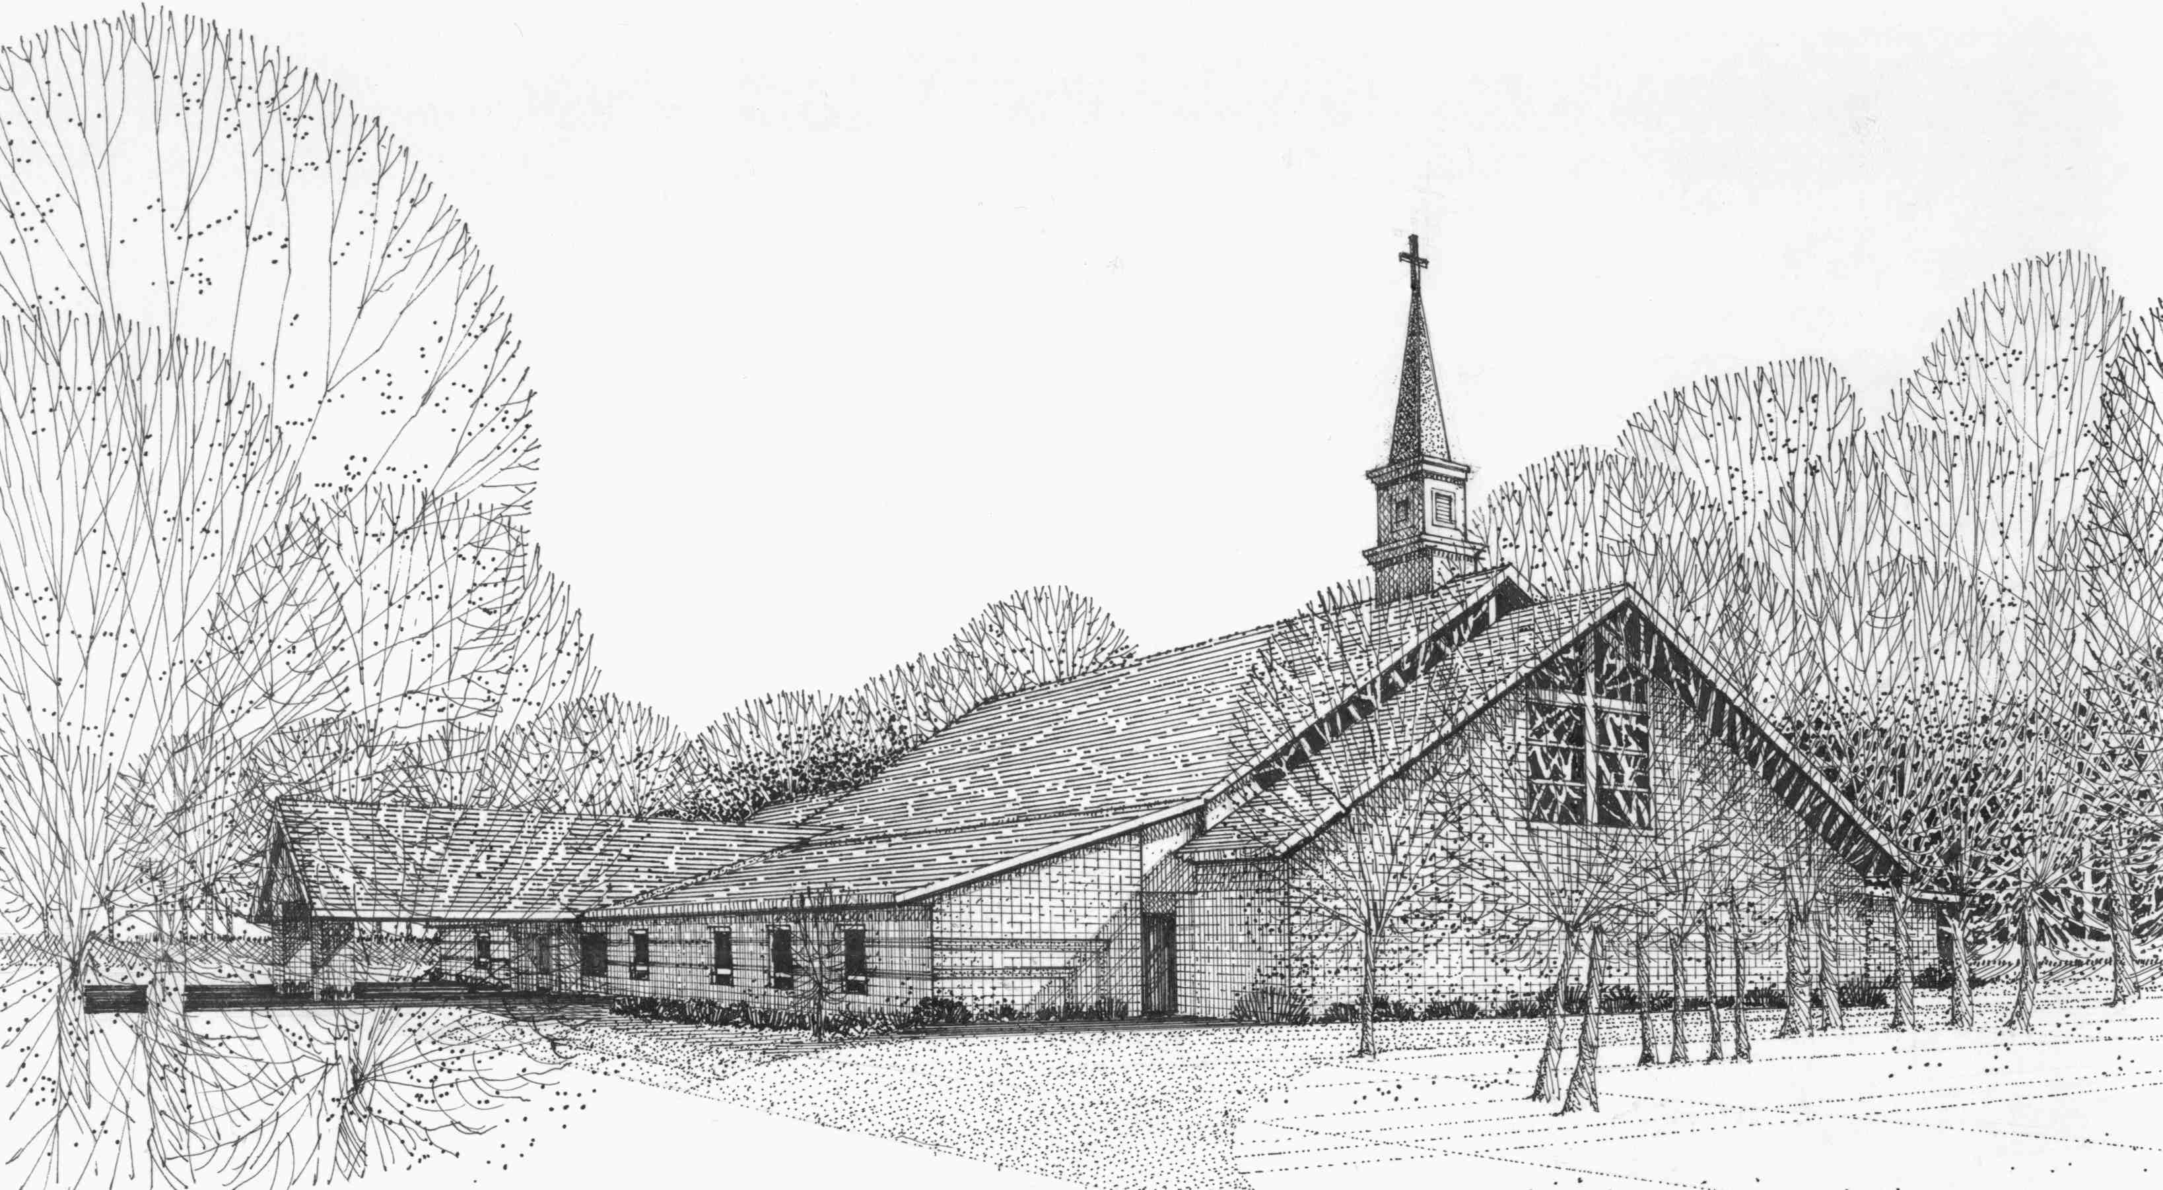

Our Vision
We are the Christian Church (Disciples of Christ) where ALL are welcome. We are faith based, following the teachings of Jesus Christ, and carrying the word to others by serving our community and beyond

First Christian Church, 4520 Rosedale Rd., Middletown, Ohio 45042
Phone: 513-422-2853 Fax: 513-422-4530
fccmiddletownoh@gmail:com
Web Site: www.fcc-middletown.org

