Prelude
Please use this time to prepare your heart and spirit for worship.

There is a prayer station in the northeast corner of the sanctuary. Please use this area at any time during the worship to pray or light a candle for someone.

If you have a prayer request, please fill out a yellow card in the pew. You may pass it toward the center aisle during the singing of the Hymn of Invitation.

Welcome & Announcements Cameron Fowler
We welcome you to this “Youth Sunday” service

* Songs of Praise Shine, Jesus, Shine (CP) #39
I Just Wanna Be a Sheep Screen

Pledges of Allegiance Ethan Otis

Opening Prayer Landen Lovin

Adult Moment Song #530
I’ve Got Peace Like a River

Adult Moment Nick Otis
Scripture Jeremiah 29:4-14 Angel Dearth
John 10:11-21 Travis Fowler/Landen Lovin
Sermon Renee Lyons
Invitation to Discipleship
If you would like to make a confession of faith or rededicate your life,
please come forward during the singing of the Invitation Hymn
or talk to Pastor Tracy following service.
* Hymn of Invitation Screen
By Faith
Pastoral Prayer & Lord’s Prayer (Prayer said with trespasses)

May 13, 2018
Communion Hymn (CP) 49
Sanctuary
Welcome to the Table Owen Lyons
Words of Institution
Communion Prayer Nick Otis
Sharing Sacred Meal
We celebrate communion every Sunday. All who believe in Jesus Christ are
welcome to partake of communion. As the bread is passed, please take and
eat. Please reserve the cup. We will share the cup together when instructed.

Offering (Invitation and Collection) Daria Dearth
* Doxology #46
* Prayer of Dedication Cameron Fowler
* Closing Hymn
You Are My Sunshine

* Benediction Daria Dearth
Postlude

* Please stand if you are able

Hearing Assistance: We have hearing assistance units available in the sound booth. Please feel free to get one at the beginning of worship. Please return to sound booth at the end of worship.

Minister: Rev. Tracy Siegman
Music Director: Rachel Eve Davis
Sound & Video Booth: Larry Steele & Connor Thompson

CALENDAR

Today: 9:30 am Sunday School
10:30 am Worship
Tuesday 7:00 pm Bible Study
Wednesday: 11:30 am Outreach serving lunch at Hope House
Women and Children’s Center
2:00 pm Bible Study
6:00 pm Choir Practice

PLEASE SEND IN NEWSLETTER ARTICLES BY NOON ON MONDAY, MAY 14th

Prayer Concerns:



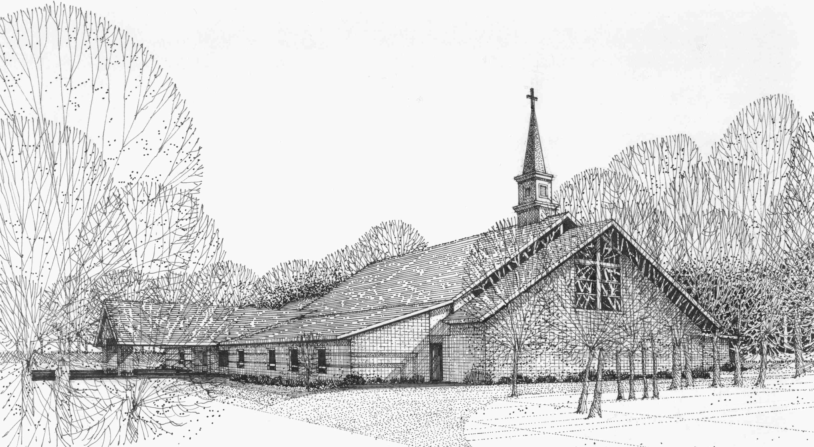

Our Vision
We are the Christian Church (Disciples of Christ) where ALL are welcome. We are faith based, following the teachings of Jesus Christ, and carrying the word to others by serving our community and beyond

First Christian Church, 4520 Rosedale Rd., Middletown, Ohio 45042
Phone: 513-422-2853 Fax: 513-422-4530
fccmiddletownoh@gmail:com
Web Site: www.fcc-middletown.org

