Prelude
Please use this time to prepare your heart and spirit for worship.

There is a prayer station in the northeast corner of the sanctuary. Please use this area at any time during the worship to pray or light a candle for someone.

If you have a prayer request, please fill out a yellow card in the pew. You may pass it toward the center aisle during the singing of the Hymn of Invitation.

Welcome & Announcements
We welcome you to this “Holy Humor Sunday” service

* Songs of Praise This is the Day #286
How Majestic Is Your Name #63

Opening Prayer

Children’s Moment Song #530
I’ve Got Peace Like a River

Children’s Moment Lora Schueller
Anthem Elijah Rock Chancel Choir
Scripture 2 Corinthians 6:3-10
Sermon “Keeping Joy ” Rev. Tracy Siegman
Invitation to Discipleship
If you would like to make a confession of faith or rededicate your life,
please come forward during the singing of the Invitation Hymn
or talk to Pastor Tracy following service.
* Hymn of Invitation #2 (v. 1,2,3)
Joyful, Joyful, We Adore Thee
Pastoral Prayer & Lord’s Prayer (Prayer said with trespasses)

May 6, 2018
Communion Hymn #424
I’m Gonna Eat at the Welcome Table
Welcome to the Table
Words of Institution
Communion Prayer
Sharing Sacred Meal
We celebrate communion every Sunday. All who believe in Jesus Christ are
welcome to partake of communion. As the bread is passed, please take and
eat. Please reserve the cup. We will share the cup together when instructed.

Offering (Invitation and Collection)
* Doxology #46
* Prayer of Dedication
* Closing Hymn #422
Let Us Talents and Tongues Employ

* Benediction
Postlude

* Please stand if you are able

Hearing Assistance: We have hearing assistance units available in the sound booth. Please feel free to get one at the beginning of worship. Please return to sound booth at the end of worship.

Minister: Rev. Tracy Siegman
Worship Leader: Larry Chamberlain
Music Director: Rachel Eve Davis
Elders: Dave Lombard, Dorice Perkins
Deacons: Brenda Gulley, Beth Heinkel, John Heinkel, Crystal Watson
Sound & Video Booth: Larry Steele & Connor Thompson

CALENDAR

Today: 9:30 am Sunday School
10:30 am Worship
1:00 pm Elders Visiting Special Needs Members
Tuesday: 4:00 pm Pastoral Relations Committee
7:00 pm Bible Study
Wednesday: 2:00 pm Bible Study
6:00 pm Choir Practice

Prayer Concerns:



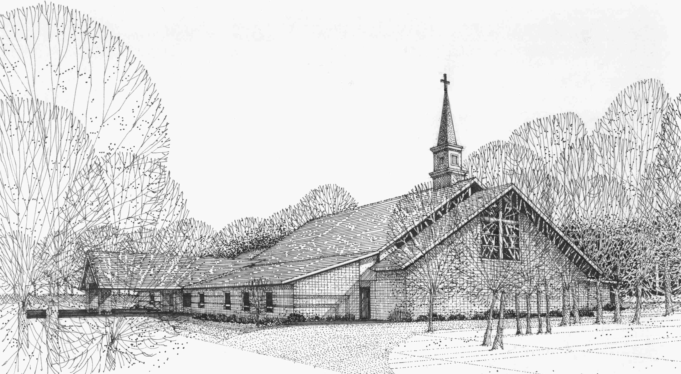

Our Vision
We are the Christian Church (Disciples of Christ) where ALL are welcome. We are faith based, following the teachings of Jesus Christ, and carrying the word to others by serving our community and beyond

First Christian Church, 4520 Rosedale Rd., Middletown, Ohio 45042
Phone: 513-422-2853 Fax: 513-422-4530
fccmiddletownoh@gmail:com
Web Site: www.fcc-middletown.org

