Prelude
Please use this time to prepare your heart and spirit for worship.

There is a prayer station in the northeast corner of the sanctuary. Please use this area at any time during the worship to pray or light a candle for someone.

If you have a prayer request, please fill out a yellow card in the pew. You may pass it toward the center aisle during the singing of the Hymn of Invitation.

Welcome & Announcements

* Songs of Praise
For the Beauty of the Earth #56 (v.1-3, 5)
I Was There to Hear Your Borning Cry #75

Opening Prayer

Children’s Moment Song
Wonderful Words of Life #323

Children’s Moment Pastor Tracy Siegman
Scripture Ecclesiastes 3
Sermon Jake Padich

Invitation to Discipleship
If you would like to make a confession of faith or rededicate your life,
please come forward during the singing of the Invitation Hymn
or talk to Pastor Tracy following service.
* Hymn of Invitation #622
Guide Me, O Thou Great Jehovah
Pastoral Prayer & Lord’s Prayer (Prayer said with trespasses)

June 17, 2018
Communion Hymn #424
I’m Gonna Eat at the Welcome Table
Welcome to the Table
Words of Institution
Communion Prayer
Sharing Sacred Meal
We celebrate communion every Sunday. All who believe in Jesus Christ are
welcome to partake of communion. As the bread is passed, please take and
eat. Please reserve the cup. We will share the cup together when instructed.

Gloria Patri #35

Offering (Invitation and Collection)
* Doxology #46
* Prayer of Dedication
* Closing Hymn #422
Let Us Talents and Tongues Employ

* Benediction
Postlude

* Please stand if you are able

Hearing Assistance: We have hearing assistance units available in the sound booth. Please feel free to get one at the beginning of worship. Please return to sound booth at the end of worship.

Minister: Rev. Tracy Siegman
Worship Leader: Karen Powers
Guest Musician: Wade Cummins
Elders: Karen Powers, Marilyn Strong
Deacons: Natalie Byrd, Heather Lyons, Zola McClish,
John Otis, Connor Thompson
Sound & Video Booth: Larry Steele & Cliff Thompson

CALENDAR

Today: 9:30 am Sunday School
10:30 am Worship
11:45 am General Board Meeting
Monday 7:00 pm Elders Meeting
Tuesday 7:00 pm Bible Study
Wednesday 2:00 pm Bible Study

Please turn in Newsletter articles by noon on Monday

Prayer Concerns:



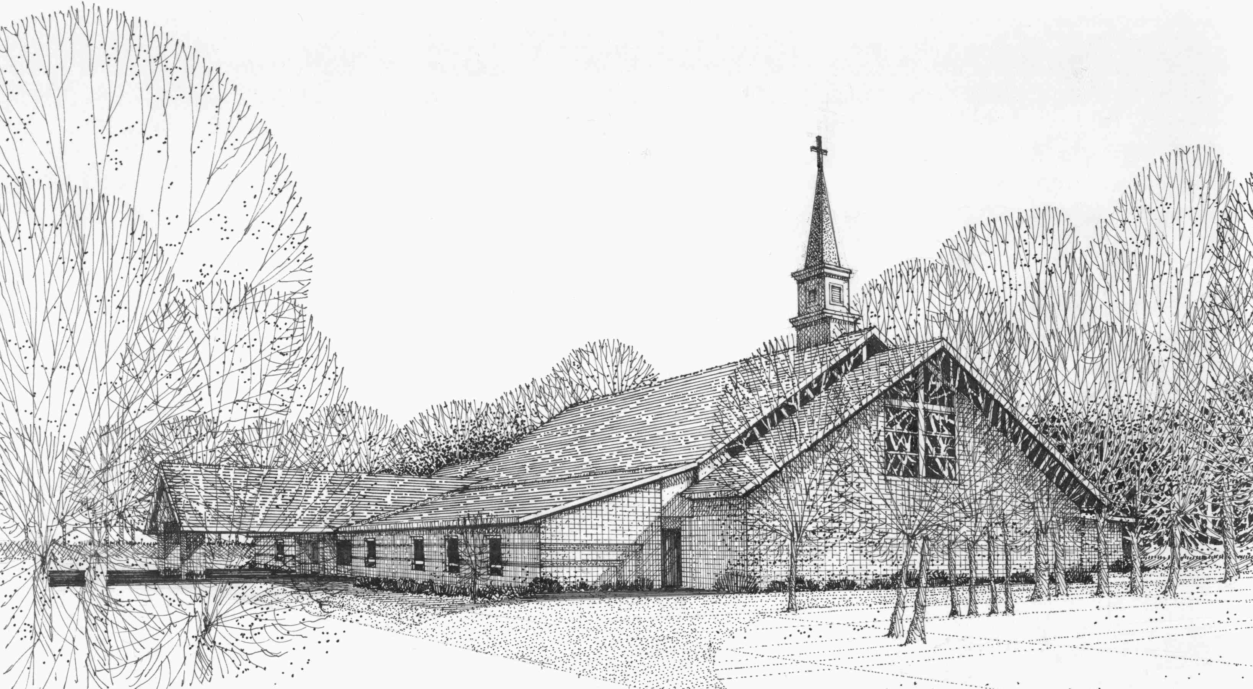

Our Vision
We are the Christian Church (Disciples of Christ) where ALL are welcome. We are faith based, following the teachings of Jesus Christ, and carrying the word to others by serving our community and beyond

First Christian Church, 4520 Rosedale Rd., Middletown, Ohio 45042
Phone: 513-422-2853 Fax: 513-422-4530
fccmiddletownoh@gmail:com
Web Site: www.fcc-middletown.org

