Prelude
Please use this time to prepare your heart and spirit for worship.

There is a prayer station in the northeast corner of the sanctuary. Please use this area at any time during the worship to pray or light a candle for someone.

If you have a prayer request, please fill out a yellow card in the pew. You may pass it toward the center aisle during the singing of the Hymn of Invitation.

Welcome & Announcements

* Songs of Praise
Open Our Eyes, Lord CP #44
Blessed Assurance #543

Opening Prayer

Children’s Moment Song
What a Friend We Have in Jesus #585

Children’s Moment Crystal Watson
Scripture 1 Chronicles 4:9-10
Sermon “The Prayer of Jabez” Pastor Tracy Siegman

Invitation to Discipleship
If you would like to make a confession of faith or rededicate your life,
please come forward during the singing of the Invitation Hymn
or talk to Pastor Tracy following service.
* Hymn of Invitation #24
The God of Abraham Praise
Pastoral Prayer & Lord’s Prayer (Prayer said with trespasses)

July 15, 2018
Communion Hymn #321
Break Thou the Bread of Life
Welcome to the Table
Words of Institution
Communion Prayer
Sharing Sacred Meal
We celebrate communion every Sunday. All who believe in Jesus Christ are
welcome to partake of communion. As the bread is passed, please take and
eat. Please reserve the cup. We will share the cup together when instructed.

Gloria Patri #35

Offering (Invitation and Collection)
* Doxology #46
* Prayer of Dedication
* Closing Hymn Screen
Knees to the Earth

* Benediction
Postlude

* Please stand if you are able

Hearing Assistance: We have hearing assistance units available in the sound booth. Please feel free to get one at the beginning of worship. Please return to sound booth at the end of worship.

Minister: Rev. Tracy Siegman
Worship Leader: John and Beth Heinkel
Music Director: Michael Hefner
Elders: Cliff Thompson, Sharon Amburgey
Deacons: John Ralbovsky, Star Ralbovsky, Connor Thompson,
Kaitlin Thompson
Sound & Video Booth: Larry Steele & Cliff Thompson

CALENDAR

Today: 9:30 am Sunday School
10:30 am Worship
Tuesday: 7:00 pm Bible Study
Wednesday: 2:00 pm Bible Study at Mt. Pleasant
Saturday: 1:00 pm Eagle Scout Ceremony

Today, we are pleased to welcome Michael Hefner as our new Music Director!

Pastor Tracy will hold office hours Monday from 2:00-6:00 pm at Java Johnny’s. On Tuesday, visit her from 2:00-6:00 pm at Triple Moon in downtown Middletown.

PLEASE SEND IN NEWSLETTER ARTICLES BY NOON ON MONDAY, JULY 15TH

Prayer Concerns:



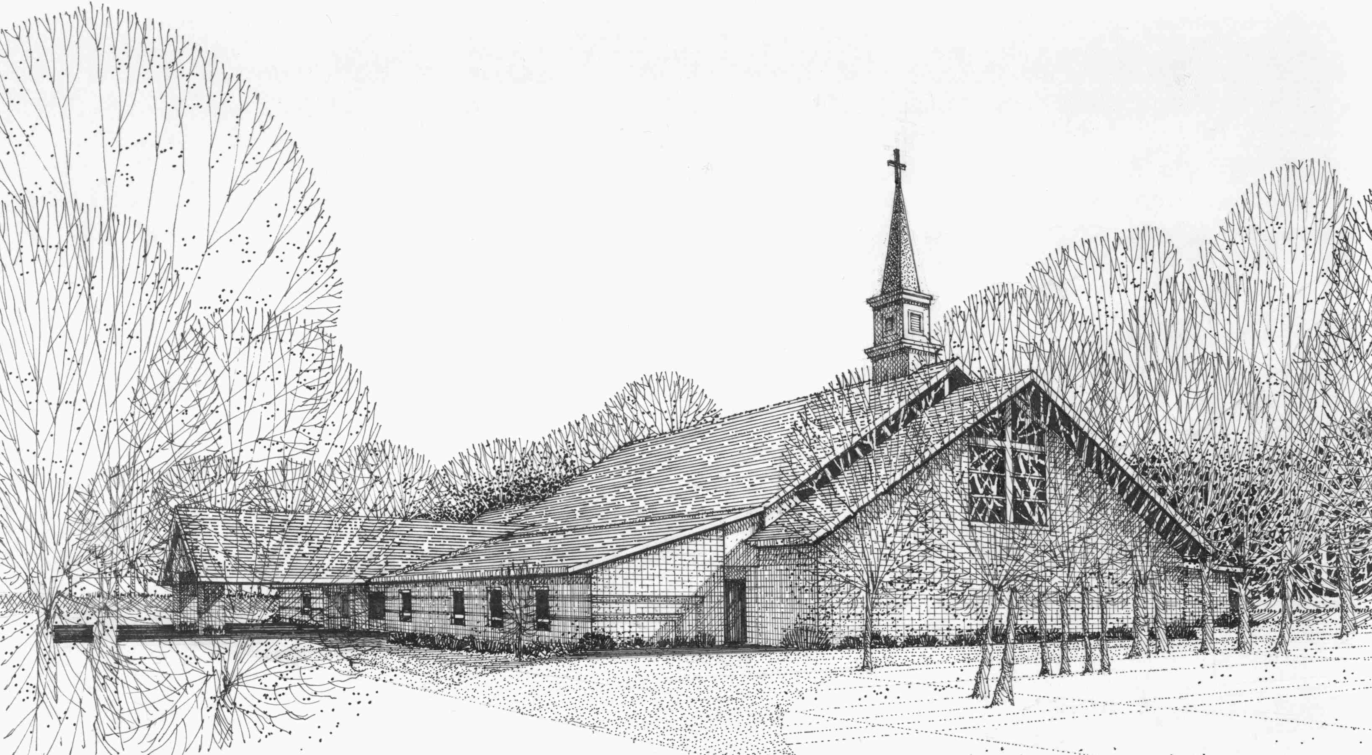

Our Vision
We are the Christian Church (Disciples of Christ) where ALL are welcome. We are faith based, following the teachings of Jesus Christ, and carrying the word to others by serving our community and beyond

First Christian Church, 4520 Rosedale Rd., Middletown, Ohio 45042
Phone: 513-422-2853 Fax: 513-422-4530
fccmiddletownoh@gmail:com
Web Site: www.fcc-middletown.org

