Prelude
Please use this time to prepare your heart and spirit for worship.

There is a prayer station in the northeast corner of the sanctuary. Please use this area at any time during the worship to pray or light a candle for someone.

If you have a prayer request, please fill out a yellow card in the pew. You may pass it toward the center aisle during the singing of the Hymn of Invitation.

Introit Razor’s Edge Barbershop Chorus

Welcome & Announcements

* Songs of Praise
The Church’s One Foundation Screen
Come, Thou Almighty King #27

Opening Prayer

Special Music Razor’s Edge Barbershop Chorus

Children’s Moment Song
All Things Bright and Beautiful #61 (v.1)

Children’s Moment Crystal Watson
Scripture Mark 5:1-13
Sermon “Healing and Christianity” Dr. David Lombard

Invitation to Discipleship
If you would like to make a confession of faith or rededicate your life,
please come forward during the singing of the Invitation Hymn
or talk to Pastor Tracy following service.
* Hymn of Invitation 588
Have Thine Own Way, Lord!

Pastoral Prayer & Lord’s Prayer (Prayer said with trespasses)
Razor’s Edge Barbershop Chorus

August 19, 2018
Communion Hymn #393
One Bread, One Body
Welcome to the Table
Words of Institution
Communion Prayer
Sharing Sacred Meal
We celebrate communion every Sunday. All who believe in Jesus Christ are
welcome to partake of communion. As the bread is passed, please take and
eat. Please reserve the cup. We will share the cup together when instructed.

Gloria Patri #36

Offering (Invitation and Collection)
* Doxology #46
* Prayer of Dedication
* Closing Hymn #110
You Servants of God

* Benediction Razor’s Edge Barbershop Chorus
Postlude

* Please stand if you are able

Hearing Assistance: We have hearing assistance units available in the sound booth. Please feel free to get one at the beginning of worship. Please return to sound booth at the end of worship.

Guest Speaker: Dr. David Lombard
Music Director: Michael Hefner
Worship Leader: Karen Powers
Elders: Sharon Amburgey, Roger Byrd
Deacons: John Ralbovsky, Star Ralbovsky, Kaitlin Thompson,
Connor Thompson
Sound & Video Booth: Larry Steele & Cliff Thompson

CALENDAR

Today: 9:30 am Sunday School
10:30 am Worship
Tuesday: 7:00 pm Bible Study

We welcome the Razor’s Edge Barbershop Chorus and their music ministry today. Music includes:
Nearer My God to Thee, Precious Lord, Let There Be Peace on Earth, The Lord’s Prayer, This Little Light of Mine and
A Parting Blessing

Please submit all newsletter articles to the Office by noon on Monday, August 20th

Prayer Concerns:



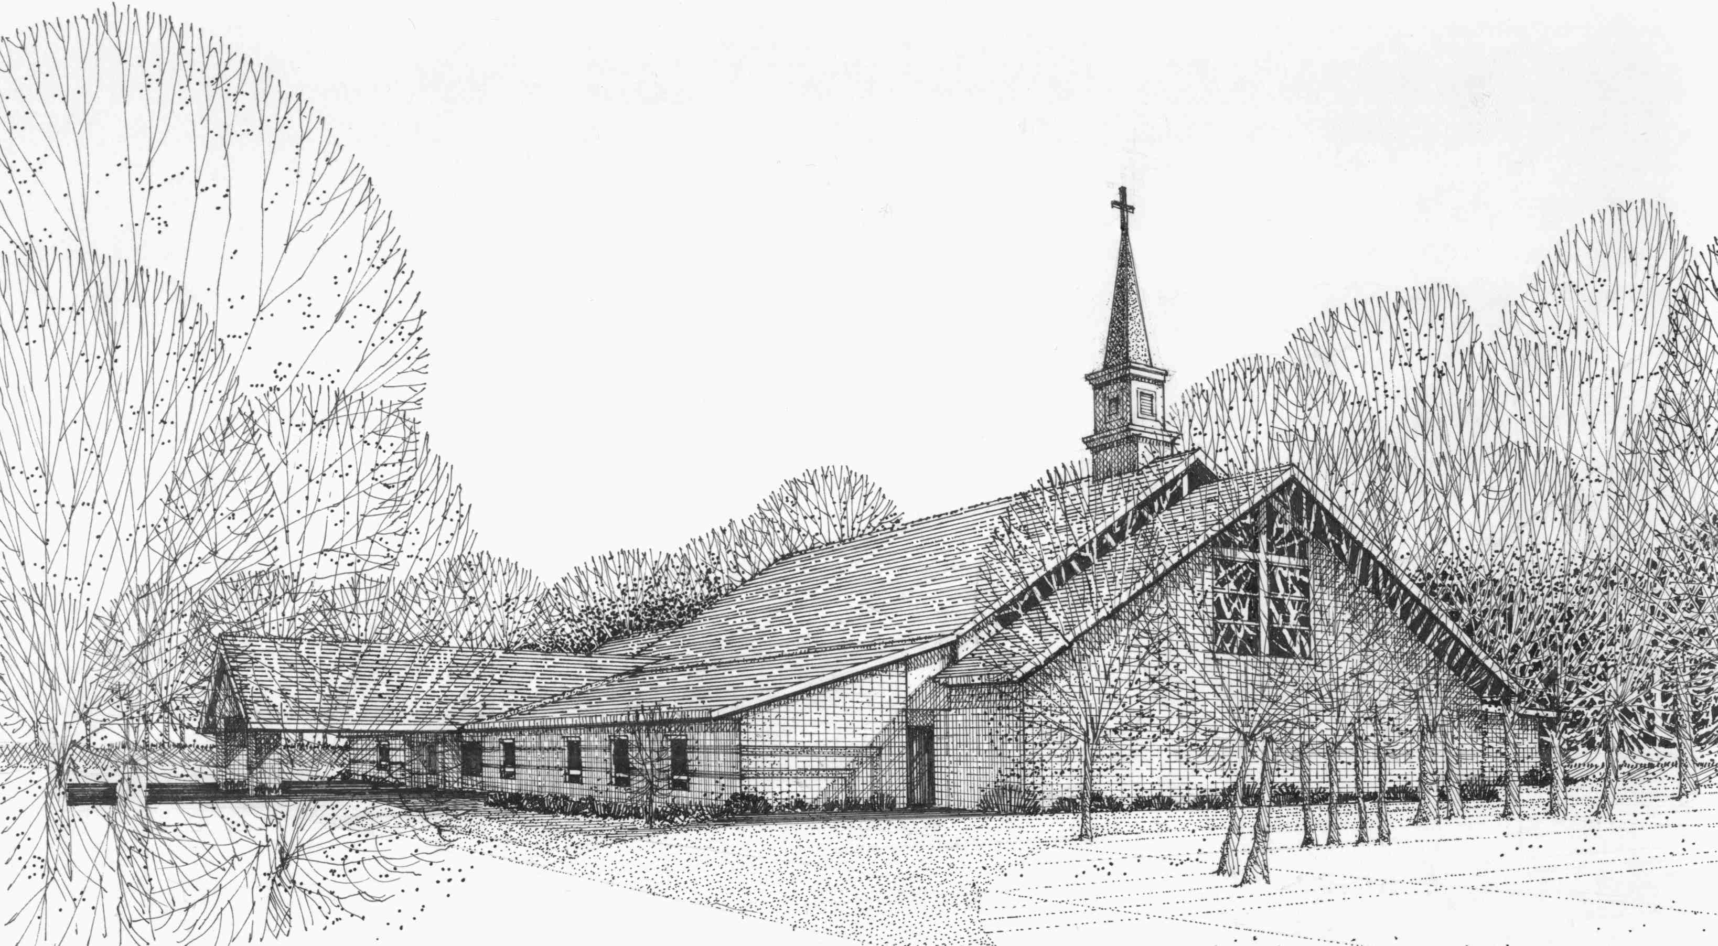

Our Vision
We are the Christian Church (Disciples of Christ) where ALL are welcome. We are faith based, following the teachings of Jesus Christ, and carrying the word to others by serving our community and beyond

First Christian Church, 4520 Rosedale Rd., Middletown, Ohio 45042
Phone: 513-422-2853 Fax: 513-422-4530
fccmiddletownoh@gmail:com
Web Site: www.fcc-middletown.org

