Prelude
Please use this time to prepare your heart and spirit for worship.

There is a prayer station in the northeast corner of the sanctuary. Please use this area at any time during the worship to pray or light a candle for someone.

If you have a prayer request, please fill out a yellow card in the pew. You may pass it toward the center aisle during the singing of the Hymn of Invitation.

Welcome & Announcements

* Songs of Praise
Rejoice, You Pure in Heart #15
Better Is One Day CP #10

Opening Prayer

Children’s Moment Song
All Things Bright and Beautiful #61 (v.1)

Children’s Moment Brenda Gulley
Scripture Psalm 27:1-14
Sermon “Whom Shall I Fear?” Pastor Tracy Siegman

Invitation to Discipleship
If you would like to make a confession of faith or rededicate your life,
please come forward during the singing of the Invitation Hymn
or talk to Pastor Tracy following service.
* Hymn of Invitation Victory in Jesus On Screen

Pastoral Prayer & Lord’s Prayer (Prayer said with trespasses)

August 5, 2018
Communion Hymn #386
We Come as Guests Invited
Welcome to the Table
Words of Institution
Communion Prayer
Sharing Sacred Meal
We celebrate communion every Sunday. All who believe in Jesus Christ are
welcome to partake of communion. As the bread is passed, please take and
eat. Please reserve the cup. We will share the cup together when instructed.

Gloria Patri #36

Offering (Invitation and Collection)
* Doxology #46
* Prayer of Dedication
* Closing Hymn Screen
Thy Word

* Benediction
Postlude

* Please stand if you are able

Hearing Assistance: We have hearing assistance units available in the sound booth. Please feel free to get one at the beginning of worship. Please return to sound booth at the end of worship.

Minister: Rev. Tracy Siegman
Music Director: Michael Hefner
Worship Leader: John Otis
Elders: Matt Lyons, Marilyn Strong
Deacons: Mary Back, Zola McClish, Angie Otis,
John Otis, Nick Otis
Sound & Video Booth: Larry Steele & Connor Thompson

CALENDAR

Today: 9:30 am Sunday School
10:30 am Worship
1:30 pm Elders Visiting Special Needs Members
Tuesday: 7:00 pm Bible Study
Wednesday: 2:00 pm Bible Study at Dorice’s residence

Pastor Tracy will hold office hours Monday from 2:00-6:00 pm at Java Johnny’s. On Tuesday, visit her from 2:00-6:00 pm at Triple Moon in downtown Middletown.

Prayer Concerns:



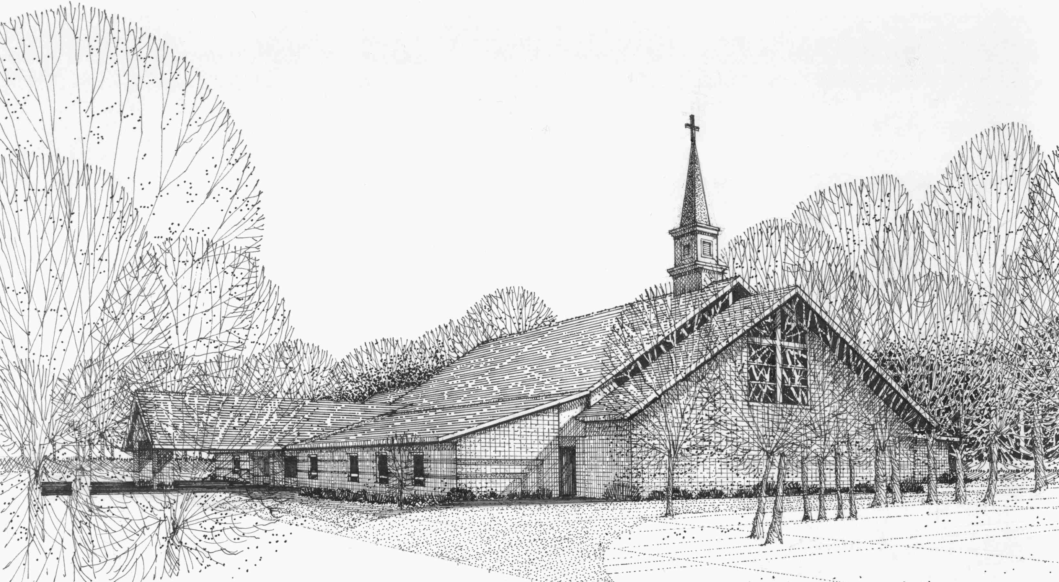

Our Vision
We are the Christian Church (Disciples of Christ) where ALL are welcome. We are faith based, following the teachings of Jesus Christ, and carrying the word to others by serving our community and beyond

First Christian Church, 4520 Rosedale Rd., Middletown, Ohio 45042
Phone: 513-422-2853 Fax: 513-422-4530
fccmiddletownoh@gmail:com
Web Site: www.fcc-middletown.org

