Prelude
Please use this time to prepare your heart and spirit for worship.

There is a prayer station in the northeast corner of the sanctuary. Please use this area at any time during the worship to pray or light a candle for someone.

If you have a prayer request, please fill out a yellow card in the pew. You may pass it toward the center aisle during the singing of the Hymn of Invitation.

Welcome & Announcements

* Songs of Praise
Love Divine, All Loves Excelling #517
Standing on the Promises #552

Opening Prayer

Children’s Moment Song
Tell Me the Stories of Jesus #190 (v.2)

Children’s Moment Brenda Gulley
Special Music A Song of Stewardship Chancel Choir
Words by James Taulman, Music by Dale Peterson, 1988

Scripture Exodus 24:15-18; 1 Kings 8:10-11; Mark 9:2, 4, 7-8
Sermon “In His Presence” Pastor Carol Oetzel

Invitation to Discipleship
If you would like to make a confession of faith or rededicate your life,
please come forward during the singing of the Invitation Hymn
or talk to an Elder following service.
* Hymn of Invitation
Make Me a Servant CP #99

Pastoral Prayer & Lord’s Prayer (Prayer said with trespasses)

September 16, 2018
Communion Hymn
Fill My Cup, Lord #351
Welcome to the Table
Words of Institution
Communion Prayer
Sharing Sacred Meal
We celebrate communion every Sunday. All who believe in Jesus Christ are
welcome to partake of communion. As the bread is passed, please take and
eat. Please reserve the cup. We will share the cup together when instructed.

Gloria Patri #36

Offering (Invitation and Collection)
* Doxology #46
* Prayer of Dedication
* Closing Hymn
We’ve a Story to Tell to the Nations #484

* Benediction
Postlude

* Please stand if you are able

Hearing Assistance: We have hearing assistance units available in the sound booth. Please feel free to get one at the beginning of worship. Please return to sound booth at the end of worship.

Guest Speaker: Rev. Carol Oetzel
Music Director: Michael Hefner
Worship Leader: Sharon Amburgey
Elders: Roger Byrd, Sharon Amburgey
Deacons: Angel Dearth, Beth Heinkel, Crystal Watson,
Daria Dearth, John Heinkel
Sound & Video Booth: Larry Steele & Connor Thompson

CALENDAR

Today: 9:30 am Sunday School
10:30 am Worship
11:50 am General Board Meeting
5:00 pm Dinner & Movie Night
Monday 7:00 pm Elders Meeting
Tuesday: 7:00 pm Bible Study
Wednesday 7:00 pm Choir Practice

We welcome back. Pastor Carol Oetzel as our pulpit guest speaker today. Carol served our congregation for 13 years and is currently the Pastor of Assimilation at Legacy Christian Church in Harrison, Ohio.

Please submit all newsletter articles by noon on Monday, September 17

Prayer Concerns:


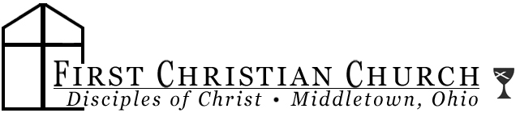
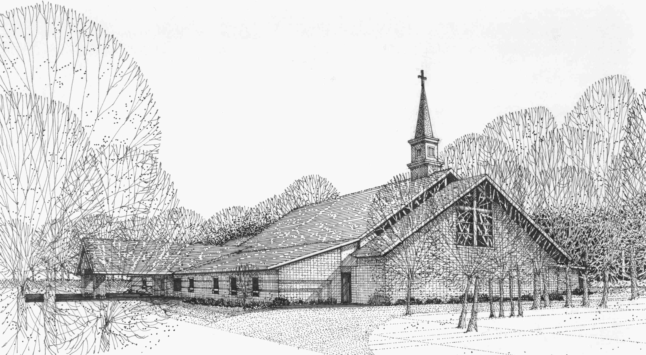

Our Vision
We are the Christian Church (Disciples of Christ) where ALL are welcome. We are faith based, following the teachings of Jesus Christ, and carrying the word to others by serving our community and beyond

First Christian Church, 4520 Rosedale Rd., Middletown, Ohio 45042
Phone: 513-422-2853 Fax: 513-422-4530
fccmiddletownoh@gmail:com
Web Site: www.fcc-middletown.org

