Prelude
Please use this time to prepare your heart and spirit for worship.

There is a prayer station in the northeast corner of the sanctuary. Please use this area at any time during the worship to pray or light a candle for someone.

If you have a prayer request, please fill out a yellow card in the pew. You may pass it toward the center aisle during the singing of the Hymn of Invitation.

Welcome & Announcements

* Songs of Praise
Praise God’s Name CP #20
Holy Ground #112

Opening Prayer

Children’s Moment Song
Tell Me the Stories of Jesus #190 (v.2)

Children’s Moment Lora Schueller
Special Music Seek the Lord Chancel Choir
By John Carter

Scripture 1 Kings 19: 1-13
Sermon “What Are You Doing Here, Elijah?”
Rev. J. Thomas Johnson

Invitation to Discipleship
If you would like to make a confession of faith or rededicate your life,
please come forward during the singing of the Invitation Hymn
or talk to an Elder following service.
* Hymn of Invitation
We Are an Offering CP #152

Pastoral Prayer & Lord’s Prayer (Prayer said with trespasses)

September 9, 2018
Communion Hymn
O Redeeming One CP #75
Welcome to the Table
Words of Institution
Communion Prayer
Sharing Sacred Meal
We celebrate communion every Sunday. All who believe in Jesus Christ are
welcome to partake of communion. As the bread is passed, please take and
eat. Please reserve the cup. We will share the cup together when instructed.

Gloria Patri #36

Offering (Invitation and Collection)
* Doxology #46
* Prayer of Dedication
* Closing Hymn
To God Be the Glory #72

* Benediction
Postlude

* Please stand if you are able

Hearing Assistance: We have hearing assistance units available in the sound booth. Please feel free to get one at the beginning of worship. Please return to sound booth at the end of worship.

Guest Speaker: Rev. J. Thomas Johnson
Music Director: Michael Hefner
Worship Leader: Tim Powers
Elders: Marilyn Strong, Matt Lyons
Deacons: Mary Back, Angie Otis, John Otis, Nick Otis, Zola McClish
Sound & Video Booth: Larry Steele & Connor Thompson

CALENDAR

Today: 9:30 am Sunday School
10:30 am Worship
5:00 pm Guy & Jackie Stone ~ 50th Wedding
Anniversary Open House at Verity Lodge
Tuesday: 7:00 pm Bible Study
Wednesday 7:00 pm Choir Practice

We welcome Rev. Dr. J. Thomas Johnson as our guest speaker today. He is currently serving as Regional Elder for the Christian Church in Ohio.

Prayer Concerns:
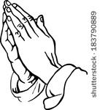


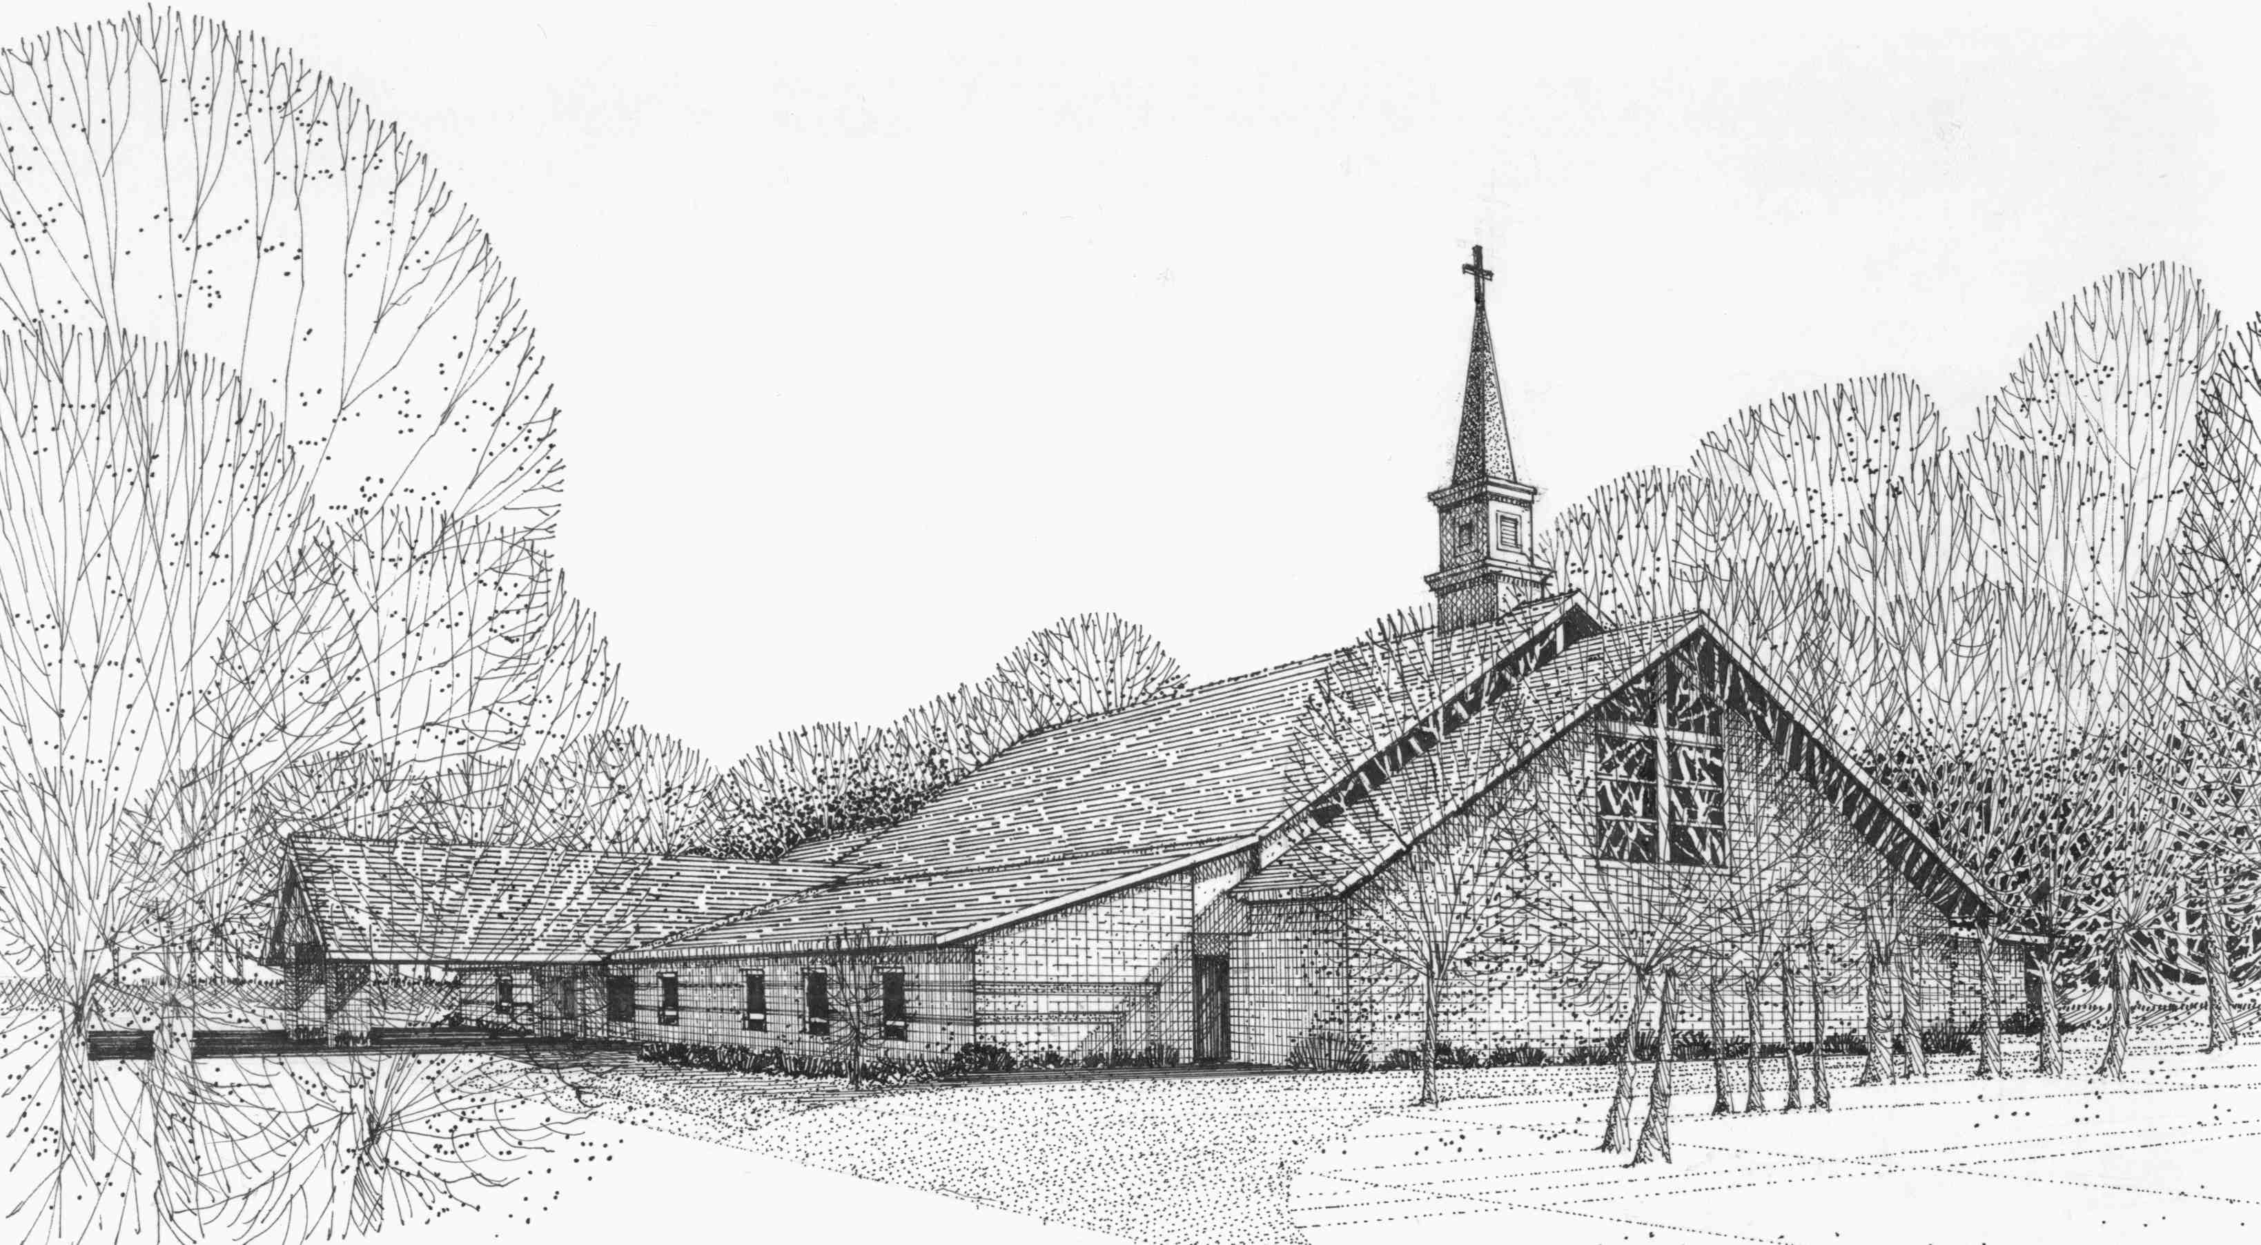

Our Vision
We are the Christian Church (Disciples of Christ) where ALL are welcome. We are faith based, following the teachings of Jesus Christ, and carrying the word to others by serving our community and beyond

First Christian Church, 4520 Rosedale Rd., Middletown, Ohio 45042
Phone: 513-422-2853 Fax: 513-422-4530
fccmiddletownoh@gmail:com
Web Site: www.fcc-middletown.org

