Prelude
Please use this time to prepare your heart and spirit for worship.

There is a prayer station in the northeast corner of the sanctuary. Please use this area at any time during the worship to pray or light a candle for someone.

If you have a prayer request, please fill out a yellow card in the pew. You may pass it toward the center aisle during the singing of the Hymn of Invitation.

Welcome & Announcements

* Songs of Praise
Praise to the Lord, the Almighty #25
Great Is Thy Faithfulness #86

Opening Prayer

Children’s Moment Song
Strong, Gentle Children #511 (v.1)

Children’s Moment Brenda Gulley
Special Music So Let Me Live Chancel Choir
Words Vida Munden Nixon, Music by Donald Wyrtzen, 1970

Scripture Job 1:6-11
Sermon “Job’s Perseverance” Cliff Thompson
Invitation to Discipleship
If you would like to make a confession of faith or rededicate your life,
please come forward during the singing of the Invitation Hymn
or talk to an Elder following service.
* Hymn of Invitation
I Bind My Heart This Tide #350

Pastoral Prayer & Lord’s Prayer (Prayer said with trespasses)

October 21, 2018
Communion Hymn
We Remember You CP #169
Welcome to the Table
Words of Institution
Communion Prayer
Sharing Sacred Meal
We celebrate communion every Sunday. All who believe in Jesus Christ are
welcome to partake of communion. As the bread is passed, please take and
eat. Please reserve the cup. We will share the cup together when instructed.

Gloria Patri #36

Offering (Invitation and Collection)
* Doxology #46
* Prayer of Dedication
* Closing Hymn
Glorious Things of Thee Are Spoken #709

* Benediction
Postlude

* Please stand if you are able

Hearing Assistance: We have hearing assistance units available in the sound booth. Please feel free to get one at the beginning of worship. Please return to sound booth at the end of worship.

Guest Speaker: Cliff Thompson
Music Director: Michael Hefner
Worship Leader: John/Star Ralbovsky
Elders: Roger Byrd, Guy Stone
Deacons: Angel Dearth, Beth Heinkel, Crystal Watson,
Daria Dearth, John Heinkel
Sound & Video Booth: Larry Steele, Connor Thompson, Landen Lovin

CALENDAR

Today: 10:30 am Worship
Monday: 7:00 pm General Board Meeting
Tuesday: 7:00 pm Bible Study
7:00 pm Civic Chorus Rehearsal
Wednesday 6:30 pm Choir Practice
7:00 pm Literacy Class
Saturday 6:00 pm Trunk or Treat

Our General Board Meetings are open to members of our congregation.

Prayer Concerns:



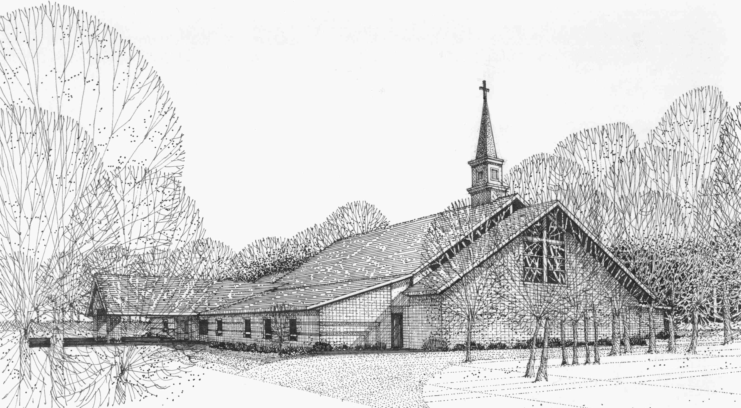

Our Vision
We are the Christian Church (Disciples of Christ) where ALL are welcome. We are faith based, following the teachings of Jesus Christ, and carrying the word to others by serving our community and beyond

First Christian Church, 4520 Rosedale Rd., Middletown, Ohio 45042
Phone: 513-422-2853 Fax: 513-422-4530
fccmiddletownoh@gmail:com
Web Site: www.fcc-middletown.org

