Prelude
Please use this time to prepare your heart and spirit for worship.

There is a prayer station in the northeast corner of the sanctuary. Please use this area at any time during the worship to pray or light a candle for someone.

If you have a prayer request, please fill out a yellow card in the pew. You may pass it toward the center aisle during the singing of the Hymn of Invitation.

Welcome & Announcements

* Songs of Praise
All Hail the Power of Jesus’ Name! #91
Gather Us In #284

Opening Prayer

Children’s Moment Song
Strong, Gentle Children #511 (v.1)

Children’s Moment Lora Schueller
Special Music Create in Me a Clean Heart Soloist Michael Hefner
Accompanist Ann Watson
Words and Music by Brown Bannister, 1982

Scripture Acts 2:42-47
Sermon “Koinonia” Rev. Wendy Taylor

Invitation to Discipleship
If you would like to make a confession of faith or rededicate your life,
please come forward during the singing of the Invitation Hymn
or talk to an Elder following service.
* Hymn of Invitation
Softly and Tenderly #340

Pastoral Prayer & Lord’s Prayer (Prayer said with trespasses)

October 14, 2018
Communion Hymn
We Remember You CP #169
Welcome to the Table
Words of Institution
Communion Prayer
Sharing Sacred Meal
We celebrate communion every Sunday. All who believe in Jesus Christ are
welcome to partake of communion. As the bread is passed, please take and
eat. Please reserve the cup. We will share the cup together when instructed.

Gloria Patri #36

Offering (Invitation and Collection)
* Doxology #46
* Prayer of Dedication
* Closing Hymn
I Love to Tell the Story #480

* Benediction
Postlude

* Please stand if you are able

Hearing Assistance: We have hearing assistance units available in the sound booth. Please feel free to get one at the beginning of worship. Please return to sound booth at the end of worship.

Guest Speaker: Rev. Wendy Taylor
Music Director: Michael Hefner
Worship Leader: Marilyn Chamberlain
Elders: Matt Lyons, Sharon Amburgey
Deacons: Angie Otis, John Otis, Mary Back, Nick Otis, Zola McClish
Sound & Video Booth: Larry Steele & Connor Thompson

CALENDAR

Today: 10:30 am Worship
Monday: 7:00 pm Elders Meeting
Tuesday: 7:00 pm Bible Study
7:00 pm Civic Chorus Rehearsal
Wednesday 6:30 pm Choir Practice
7:00 pm Literacy Class

Reminder that all newsletter articles are due by noon tomorrow.

We welcome Rev. Wendy Taylor as our pulpit guest speaker today. Wendy is Pastor of the Delaware Project and responsible for the Free Store at Camp Christian.

We welcome Ann Watson as our guest accompanist!

Prayer Concerns:



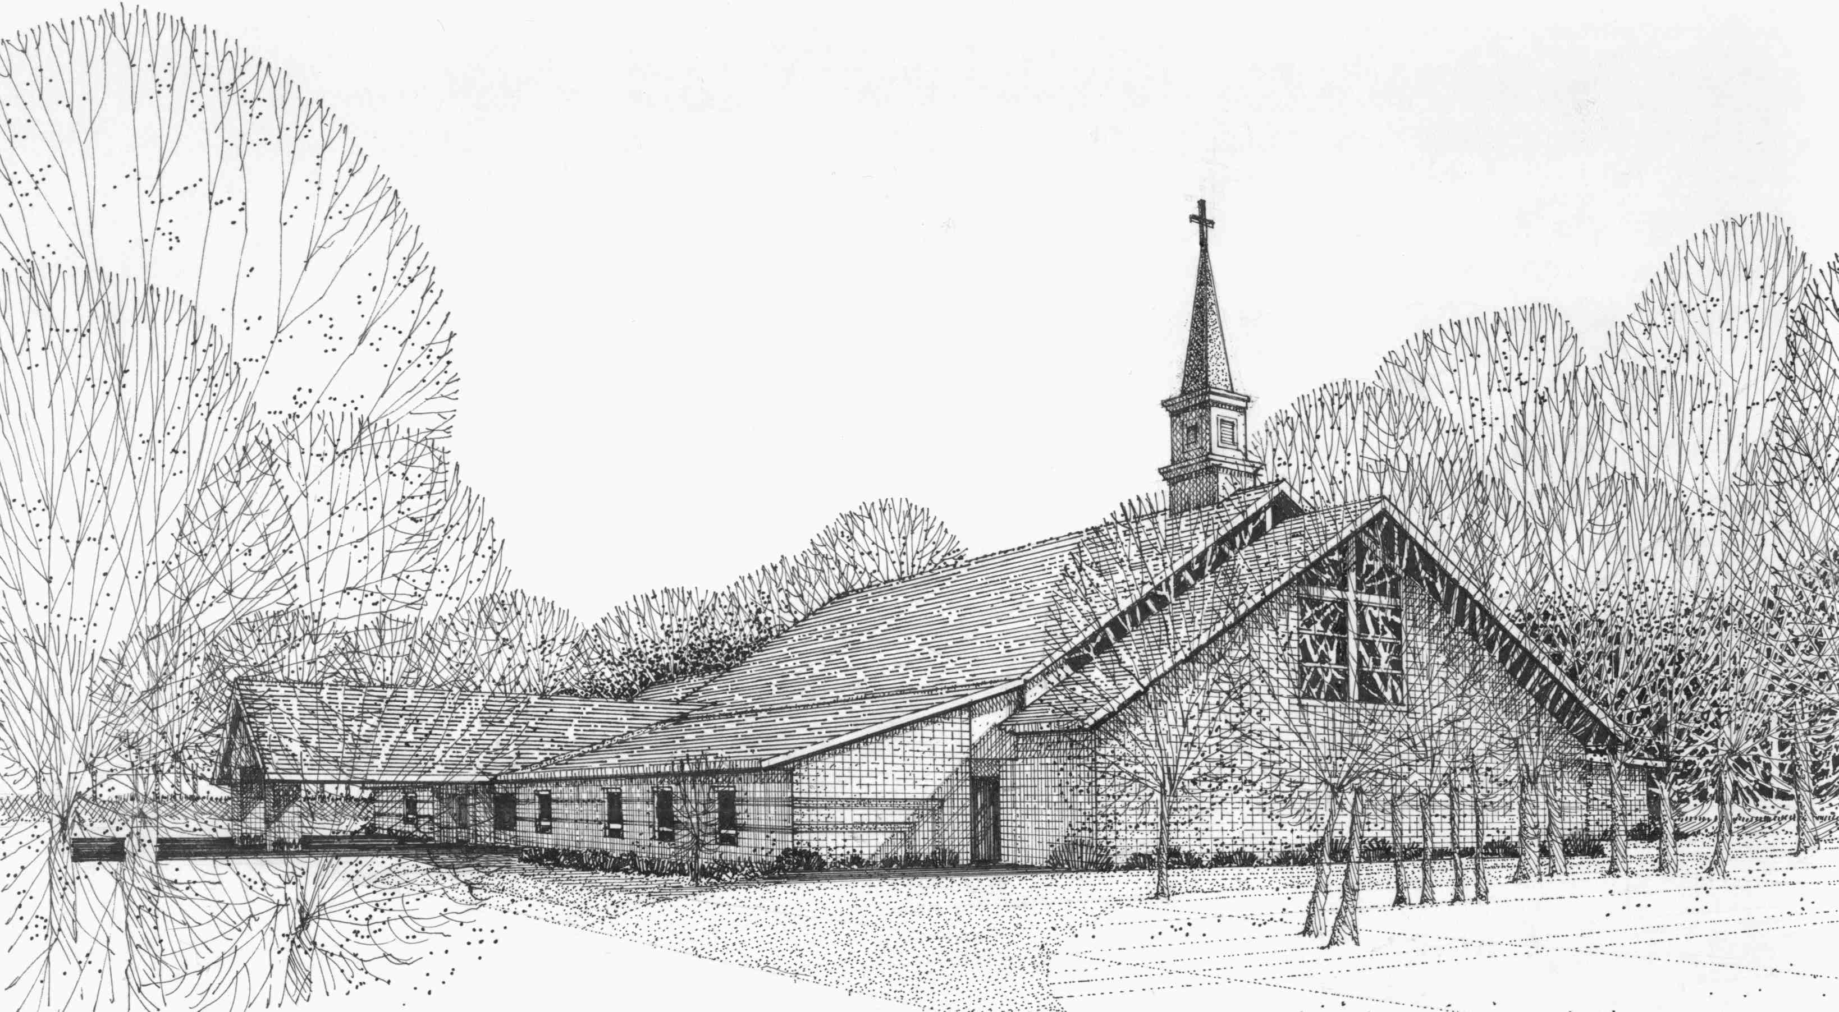

Our Vision
We are the Christian Church (Disciples of Christ) where ALL are welcome. We are faith based, following the teachings of Jesus Christ, and carrying the word to others by serving our community and beyond

First Christian Church, 4520 Rosedale Rd., Middletown, Ohio 45042
Phone: 513-422-2853 Fax: 513-422-4530
fccmiddletownoh@gmail:com
Web Site: www.fcc-middletown.org

