Prelude
Please use this time to prepare your heart and spirit for worship.

There is a prayer station in the northeast corner of the sanctuary. Please use this area at any time during the worship to pray or light a candle for someone.

If you have a prayer request, please fill out a yellow card in the pew. You may pass it toward the center aisle during the singing of the Hymn of Invitation.

Welcome & Announcements

* Songs of Praise
Majesty CP #50
Immortal, Invisible, God Only Wise #66

Opening Prayer

Children’s Moment Song
Strong, Gentle Children #511 (v.1)

Children’s Moment Heather Lyons
Special Music Trust In the Lord Chancel Choir & Tamy Ward
Words by Mary Kay Beall, Music by John Carter, 1998

Scripture 1 Corinthians 13:8-13
Sermon “The Gift is Love” Rev. Ed Bastien

Invitation to Discipleship
If you would like to make a confession of faith or rededicate your life,
please come forward during the singing of the Invitation Hymn
or talk to an Elder following service.
* Hymn of Invitation
We Are an Offering CP #152

Pastoral Prayer & Lord’s Prayer (Prayer said with trespasses)

October 7, 2018
Communion Hymn
Come to the Table Again CP #13
Welcome to the Table
Words of Institution
Communion Prayer
Sharing Sacred Meal
We celebrate communion every Sunday. All who believe in Jesus Christ are
welcome to partake of communion. As the bread is passed, please take and
eat. Please reserve the cup. We will share the cup together when instructed.

Gloria Patri #36

Offering (Invitation and Collection)
* Doxology #46
* Prayer of Dedication
* Closing Hymn
We Are Called to Follow Jesus #465

* Benediction
Postlude

* Please stand if you are able

Hearing Assistance: We have hearing assistance units available in the sound booth. Please feel free to get one at the beginning of worship. Please return to sound booth at the end of worship.

Guest Speaker: Rev. Ed Bastien
Music Director: Michael Hefner
Worship Leader: Cliff Thompson
Elders: Cliff Thompson, Marilyn Strong
Deacons: Heather Lyons, Lora Schueller, Natalie Byrd,
Owen Lyons, Renee Lyons
Sound & Video Booth: Larry Steele & Connor Thompson

CALENDAR

Today: 10:30 am Worship
11:45 am Special Board Meeting
1:30 pm Elders Visiting Special Needs Members
Tuesday: 7:00 pm Bible Study
Wednesday 6:30 pm Choir Practice
7:00 pm Literacy Class

We welcome Rev. Ed Bastian as our pulpit guest speaker today. He is the Pastoral Care Manager at Atrium Medical Center.

Prayer Concerns:



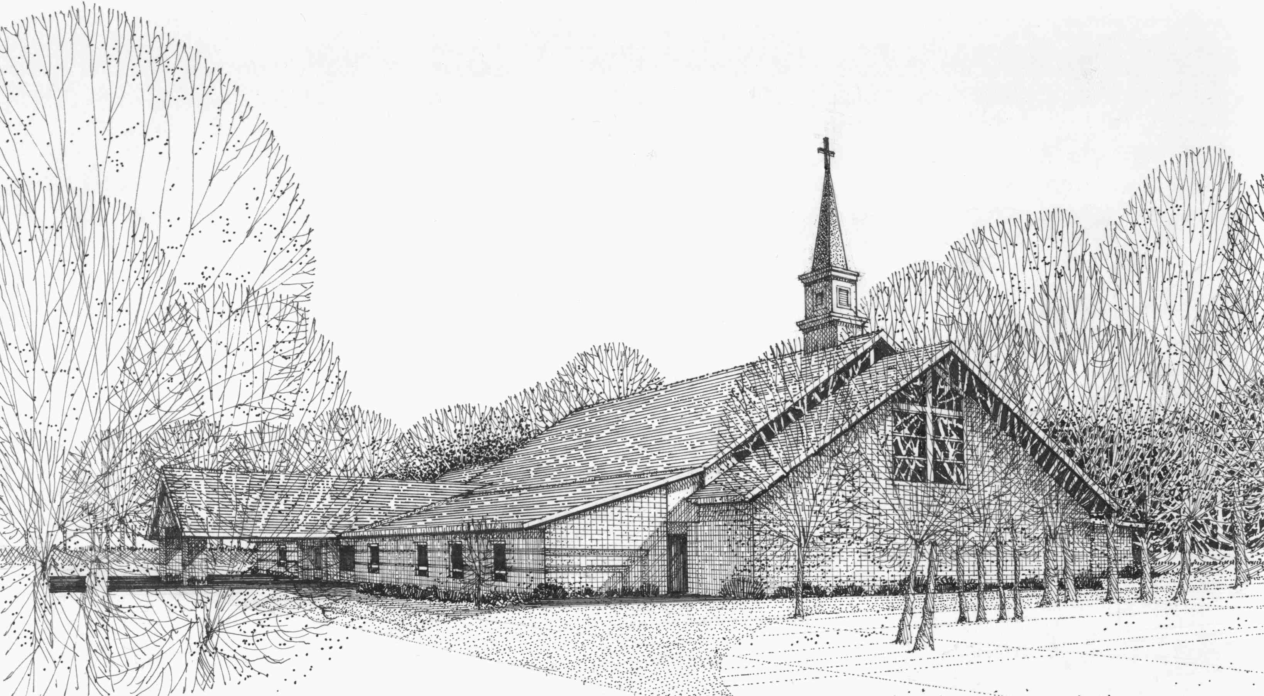

Our Vision
We are the Christian Church (Disciples of Christ) where ALL are welcome. We are faith based, following the teachings of Jesus Christ, and carrying the word to others by serving our community and beyond

First Christian Church, 4520 Rosedale Rd., Middletown, Ohio 45042
Phone: 513-422-2853 Fax: 513-422-4530
fccmiddletownoh@gmail:com
Web Site: www.fcc-middletown.org

